7.23

Stock market as a pie is getting smaller, there is not much profits to be extracted from this market.

Hedging error is pretty big now.

Financials are rising vs. all the rest of the stocks.

7.24

IB: trading shanghai, Shenzhen connect: 0.08% fee (high)

CM securities: too many questions.

China: long term investing is shit. Gradually reposition back to North America.

Food/water/drink/environment quality problem. Long term not good for health.

Don’t want to live with parents/live at home.

Study for LSAT, take it on Oct 14th.

$ needs to be out thru HB, use account that has the most in/out transfer, this arouses the least suspicion.

Before, the reason want to stay in Asia:

1. Close to family (no longer the case)
2. Food better (now prefer a variety of other food, also beef, lamb not good in china, portion getting smaller, quality sinks like in Shunde)
3. Asia was developing faster (now no longer the case)
4. Asia is easier to make money, easy to be in manager positions (not working now, can be anywhere)

**Now real issues**

1. Food safety, pollution
2. Environment
3. Untrustworthy people
4. High hidden taxes on cars etc.
5. No more career growth
6. High rent – costs more in cad $ to live in Shenzhen than Vancouver.
7. Scammers
8. Fake news, fake relationships, fake people, overall culture of fakeness
9. Materialism, money based values

Plans:

1. Try to go back to school, get a law degree, get license to practice (not necessarily practicing)
2. Invest on the side, don’t do it as a full time job, it doesn’t make money. Make sure it makes logical sense and is doable in the long run.
3. Even if investment is successful, it doesn’t come with any social recognition
4. People hate finance related majors, they are the bloodsuckers of modern economy with no contribution

7.27

Weekly review:

Stocks:

-13k

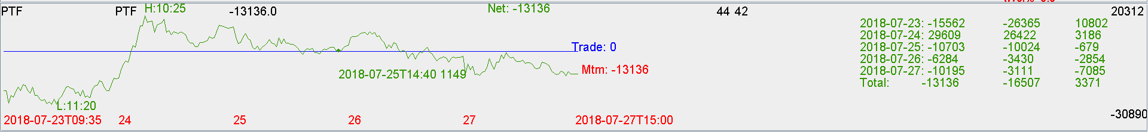

Futures:

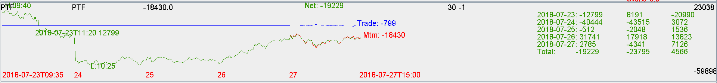

Overall:

Financial outperformed the rest this week.

Ptf delta increased from -400k to 200k (delta added on fri).

MA above 20dma, treat it as bullish market.

